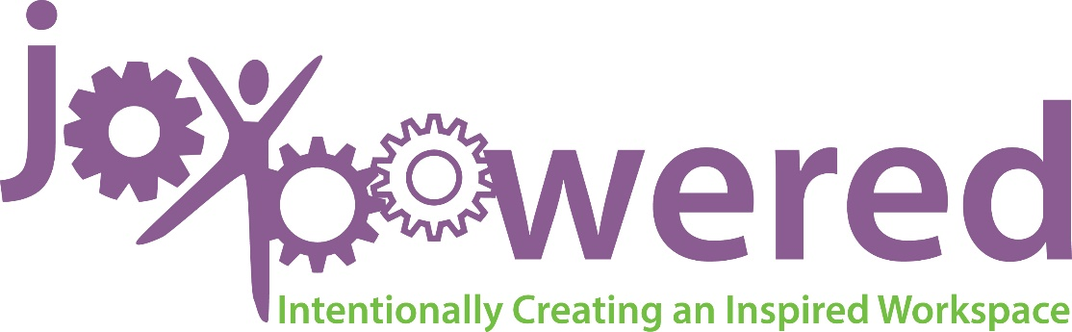

What You’ll Learn:
- Naming and claiming your Strengths
- Understanding the talents and Strengths of others
- Knowing when it’s time to quit
- Being intentional and moving forward

“What will happen when we think about what is right with people instead of fixating on what is wrong with them?”
– Donald O. Clifton, psychologist and business executive

JoDee Curtis, SHRM-SCP, CPA, Founder of Purple Ink and author of the book JoyPowered™, published in August 2016 talks about creating a dynamic and inspired workspace. JoyPowered™ helps organizations and individuals understand how to structure their relationships and environments to focus on their strengths, bringing out the best in others and themselves. Most people settle for a tolerable workplace, but JoDee challenges you to help make yourself and your workspace JoyPowered™! It starts with you, and understanding your Strengths!*

Signed copies of JoyPowered™: Intentionally Creating an Inspired Workspace will be for sale for $10.

*Although it is not necessary for you to take the Gallup® StrengthsFinder assessment prior to the presentation, we highly recommend it. You can access the assessment at www.gallupstrengthscenter.com and the cost is $15. Bring your top 5 Strengths report to the meeting.

